# 情形1、

Dynatrace Client 6.5.38.1014 与 Dynatrace Server 6.5.38.1014 连接测试超时，10次以上没有一次测试成功，连接成功率0%

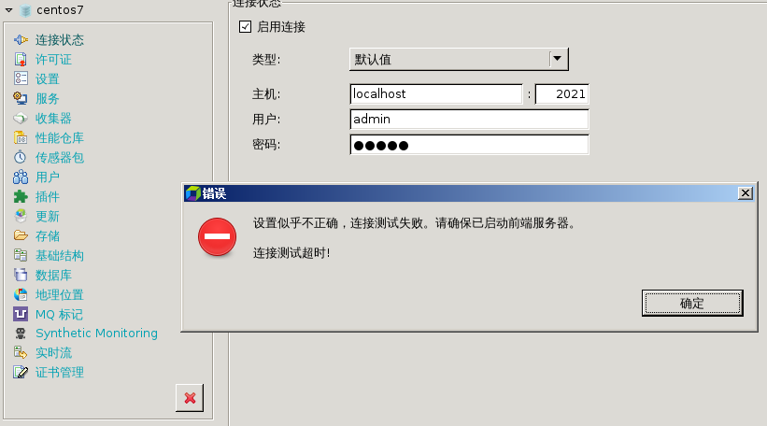

后台FrontEndServer异常日志如下：

2018-10-11 13:42:47 WARNING [DefaultSocketHandlerRunnable] closing connection (reason: 'socket reached end of stream') Released-centos7:56900:Inbound:Encrypted:LZ4:66cff90b-941c-4c09-8a99-0a74d7b50af7. Connection has been lost in Thread: ClientCommunication-Released-centos7:56900:Inbound:Encrypted:LZ4:66cff90b-941c-4c09-8a99-0a74d7b50af7-Listener: com.dynatrace.diagnostics.communication.tcp.connection.SocketConnection logConnectionWillBeClosedMessage:316

java.io.EOFException

at java.io.DataInputStream.readInt(DataInputStream.java:392)

at com.dynatrace.diagnostics.sdk.io.streams.ConditionallyDecompressingInputStream.readCompressedChunk(ConditionallyDecompressingInputStream.java:27)

at com.dynatrace.diagnostics.sdk.io.streams.CompressedInputStream.readChunk(CompressedInputStream.java:26)

at com.dynatrace.diagnostics.sdk.io.streams.ChunkedInputStream.readNextChunk(ChunkedInputStream.java:195)

at com.dynatrace.diagnostics.sdk.io.streams.ChunkedInputStream.read(ChunkedInputStream.java:115)

at com.dynatrace.diagnostics.sdk.io.streams.IoStatsAwareInputStream.read(IoStatsAwareInputStream.java:23)

at java.io.DataInputStream.readByte(DataInputStream.java:265)

at com.dynatrace.diagnostics.sdk.io.DataInputStreamDataInput.readByte(DataInputStreamDataInput.java:51)

at com.dynatrace.diagnostics.communication.tcp.connection.DefaultSocketHeaderReaderWriter30.readHeader(DefaultSocketHeaderReaderWriter30.java:38)

at com.dynatrace.diagnostics.communication.tcp.connection.DefaultSocketHeaderReaderWriter30.readHeader(DefaultSocketHeaderReaderWriter30.java:25)

at com.dynatrace.diagnostics.communication.tcp.socket.DefaultSocketHandlerRunnable.handleRequest(DefaultSocketHandlerRunnable.java:65)

at com.dynatrace.diagnostics.communication.tcp.socket.DefaultSocketHandlerRunnable.execute(DefaultSocketHandlerRunnable.java:55)

at com.dynatrace.diagnostics.util.threads.StatusRunnable.run(StatusRunnable.java:46)

at java.util.concurrent.ThreadPoolExecutor.runWorker(ThreadPoolExecutor.java:1142)

at java.util.concurrent.ThreadPoolExecutor$Worker.run(ThreadPoolExecutor.java:617)

at java.lang.Thread.run(Thread.java:745)

此外，Dynatrace Server日志均正常，无任何问题。

# 情形2、

Dynatrace Client 6.5.13.1014 与Dynatrace Server 6.5.38.1014 连接测试不稳定，成功率10%以内（偶尔会有成功），但可以正常连接Server，并正常获取Server上的配置文件。

